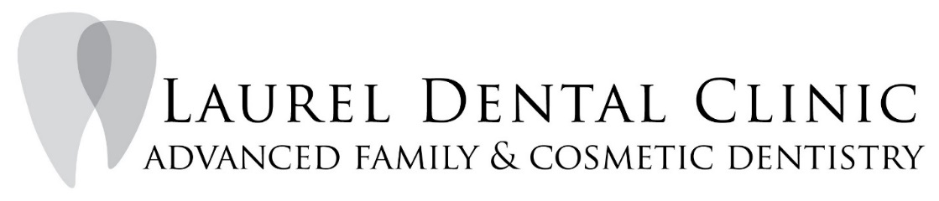
104 West 3rd Street Port Angeles, WA 98362
Phone (360)452-9744 Fax (855)291-6217
office@laureldentalclinic.net
AUTHORIZATION FOR RELEASE OF DENTAL RECORDS
For transfer of records TO Laurel Dental Clinic
For transfer of records FROM Laurel Dental Clinic

I, _____________________________________ (print name), hereby request the disclosure of information from my dental records on file with your office.

Patient Name: ______________________________________________ Date of Birth: ____________________

Address: ______________________________________________________________________________

______________________________________________________________________________

Phone: ______________________________________________________________________________

Previous Dental Office/Doctor:____________________________________________________________________

Patient/ Guardian Signature: _________________________________________________ Date: _______________

TO BE COMPLETED BY PREVIOUS DENTIST

Date of Last Prophy/ Perio Maintenance/ Scaling Root Planing:

_____________________________________________________________________________________________

Date of Last FMX/ Pano/ BWX:
_____________________________________________________________________________________________

